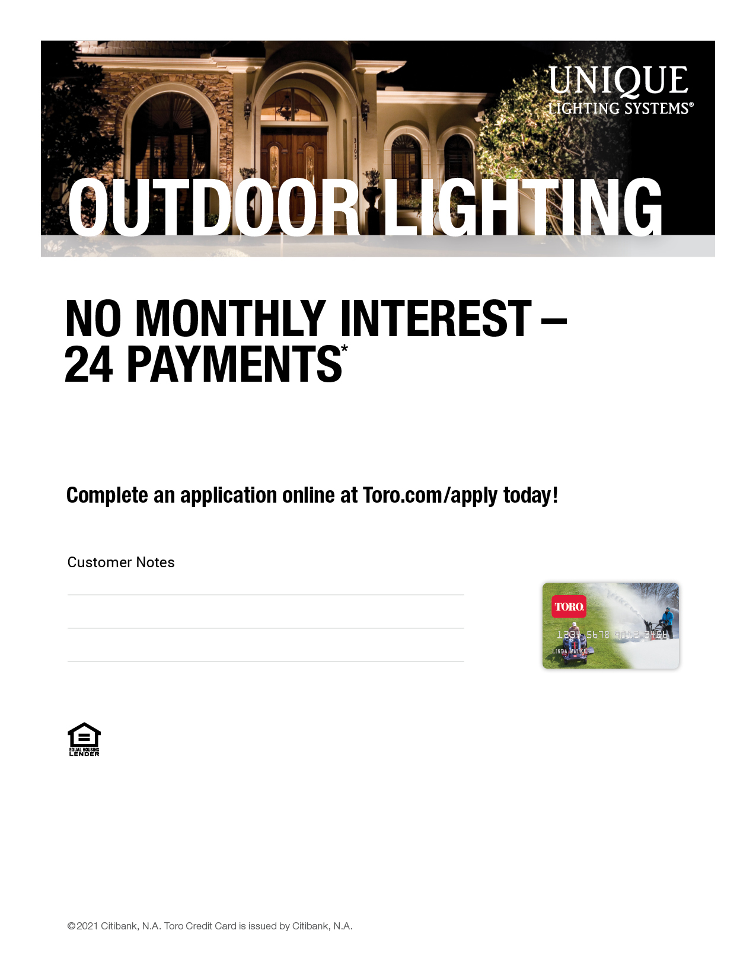

on purchases of $3,000 or more when you use the Toro Credit Card.

A Major Purchase Plan fee of $150 will be added to the Major Purchase Plan purchase amount. Offer valid 2/1/21 – 4/30/21.

 \*With credit approval for qualifying purchases made on the Toro Credit Card at participating contractors. 0% APR on installation of Unique Lighting System component purchases of $3,000 or more until balance is paid in full. The amount of the 24 monthly payments will be equal to the total purchase amount (including taxes) plus the Major Purchase Plan Fee divided by 24, rounded up to the nearest dollar. If you have other balances or late payments on your account, the number of monthly payments advertised may not pay off the balance. See card agreement for details. Offer valid for consumer accounts in good standing; see contractor for details. May not be combined with any other credit promotion offer.

TORO-UL24SF-XXXX

Contractor Logo Here