CONTRACTOR
ADVISORY
BULLETIN

Unique Lighting Contractors – U.S.
Date: February 1, 2019
To: Contractors Installing Unique Lighting Systems
From: David Adams, Senior Manager, Financial Services
Subject: Toro Credit Card Retail Finance Programs February 1 – April 30, 2019

See the attached menu for full details of Toro’s spring (February 1 – April 30, 2019) retail finance promotions for lighting installations. You’ll find the following great options for your customers.
- $100 Customer rebate offer via a pre-paid Visa debit card OR
- No interest for 24-months
Customer $100 Visa Debit Card Rebate Offer on Toro Card Purchases > $1499
You can give your customers an automatic $100 rebate in the form of a Visa pre-paid debit card when they choose 12 months deferred interest financing on the Toro card!
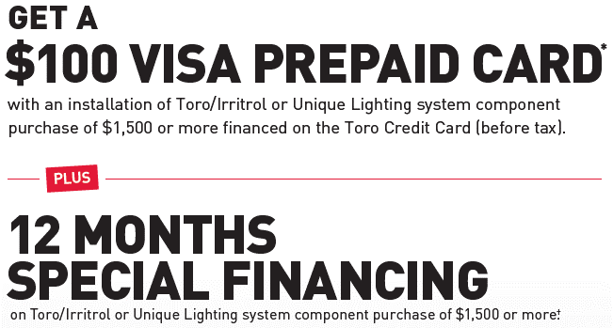 |  |  |  |  |  | DETAILS
* All lighting fixtures must be Unique
* No customer promo fee!
 |  |  |  |  |  | * No documents to submit!
 |  |  |  |  |  | * Customer will receive in mail 8-10 weeks
 |  |  |  |  |  | * No contractor cost!
Attachments
* Promotion Menu
* Customer Rebate Certificate
* Rebate Instructions
* Customer Promotion Flyer with editable fields for your logo or notes
* “Dealer” (Contractor) Enrollment Application
Toro Credit Card (Citi) Program Enrollment
Be sure you’re enrolled in the Toro credit card program to take advantage of our incredible retail financing promotions! Simply complete the attached application titled “Toro Credit Card Dealer Application” and email to Citi at ccsdealerapplications@citi.com. Call Citi’s Merchant Services at 866-786-2026 with any questions.
IMPORTANT!: On the enrollment application where asked for your “Toro Dealer #” be sure to input “Lighting”. This lets Citi know you are a Unique Lighting contractor which qualifies you for the proper promotions.
Once enrolled, expect to receive a phone call from Citi, and later, a Welcome Kit with the information you need to use the program roughly five business days after your approval.
Customer Brochures
Your Welcome Kit will contain a letter to you, as an irrigation or lighting contractor, with instructions on how to order a supply of informational customer brochures at no charge.
Contractor Training
View a video showing how to process customer credit applications and sales transactions on the Toro credit card at any time by using this link, https://www.youtube.com/watch?v=x3YStqkicKM.
Please contact your Toro regional sales manager with any questions regarding these promotions or:
David Adams - david.r.adams@toro.com, 952-887-8834
Cheri Zweber – cheri.zweber@toro.com, 952-887-8805

